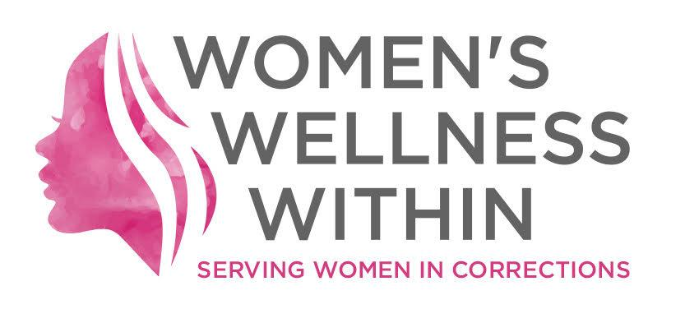

Women’s Wellness Within Statement in Support of Wet'suwet'en Land Defenders

January 9, 2019 (K’jiuktuk - Halifax, NS) - Women’s Wellness Within objects to the arrest and detention of 14 Indigenous activists, women and Elders at the Gidimt’en check point on Morice River Road, in We’suwet’en territory in the interior of British Columbia.
We reject the increasing criminalization of Indigenous activism at home in Mi’kma’ki – led increasingly by strong women throughout this territory – and across Canada.
Indigenous women are the fastest growing demographic in Canada’s prisons. This is due, in no small part, to the historic systemic violence perpetrated by the state through the legacy of the residential school system, the failure of culturally appropriate child welfare provisions for Indigenous children and continued social, environmental and economic racism across our country.
We are calling on the provincial and federal Crown to cease the sanction of armed intervention in peaceful Indigenous protest and for the release of the 14 activists arrested at Gidimt’en.

