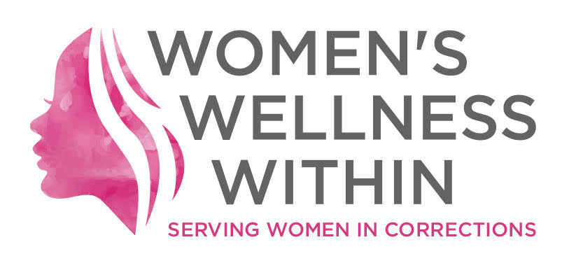
For Immediate Release

Women’s Wellness Within answers the Call: Let’s Talk about Prisoners’ Mental Health

January 30, 2018 (K’jiuktuk - Halifax, NS) – On January 30, 2019, in light of Bell Canada’s “Let’s Talk” campaign, Women’s Wellness Within would like to take the opportunity to join our friends with the Jail Accountability and Information Line (JAIL) in highlighting the importance of mental health for prisoners in Canada. Limiting communication for incarcerated Canadians exacerbates the already pronounced effects of confinement on prisoners’ mental health. We are asking our decision-makers to prioritize the mental health of all Canadians.

Last year, Women’s Wellness Within called out Bell Canada for its role in limiting federal prisoners’ telephone access given how restriction impacts not only the mental health of those on the inside, but also families on the outside. We appealed to Minister Goodale to update CSC rules and regulations on access to - and the hefty costs for - phone calls.

In 2019, we are again asking Bell to “Walk the Talk” by making all phone calls free for prisoners, if not everyday, at least on January 30. We also want to express our support and solidarity for JAIL’s #BellLetsTalkOCDC campaign. Women’s Wellness Within is calling ALL correctional facilities in Canada - both federal and provincial - to allow prisoners to make collect calls to cellular phones.

This year we also want to draw attention to the restriction of communication at correctional facilities in Canada: federal and provincial. Simply put: limiting the means and frequency of communication with families and loved ones has a negative impact on prisoners’ mental health.

At provincially run correctional facilities in Nova Scotia, prisoner phone access is controlled by facility administrators, while the provision of phone service itself is contracted out to an American firm – Synergy – that profits from each prisoner’s calls.

This past summer prisoners at the Central Nova Scotia Correctional Facility (‘Burnside’) engaged in a non-violent protest in solidarity with prisoners in the United States. Their demands were simple, clear, and aimed at securing humane treatment for all prisoners and enhanced opportunities for rehabilitation. Among their well-reasoned list of requests, prisoners asked for better health care, contact visits with their families, and more effective programming aimed at reintegration into the community once their period of incarceration had come to an end.

It’s worth noting the continued absence of adequate rehabilitation programming in spite of a commitment made by Synergy that a portion of its proceeds – earned directly from the prisoners themselves – would be invested back into the prison with an aim at providing rehabilitation services.
Women’s Wellness Within asks: where does this money go? Will Nova Scotia speak directly to the money Synergy invests back into provincial correctional facilities? Will Nova Scotia end the practice of charging prisoners to speak to their families?

On January 30, 2019, Women’s Wellness Within asks you to consider how limited contact with your families and loved ones would impact your mental health. We ask you to join our call on federal and provincial decision-makers to “Walk the Talk” and end inhumane restrictions on communication in our prisons throughout Canada.

For further information, please contact:
Martha Paynter, Chair, Women’s Wellness Within (902) 292-7082

Visit us online at womenswellnesswithin.org

